What is Digital PESTLE?
Digital PESTLE is a strategic analysis framework used to examine how external factors, particularly those related to digital technology and the digital environment, can affect a business or organisation.
PESTLE stands for:
Factor | Meaning | Digital Focus
P – Political | Government and political factors | Digital policies, government technology initiatives, internet regulations
E – Economic | Economic conditions | Digital economy, e-commerce costs, technology investment
S – Social | Changes in society and customer behaviour | Social media, digital lifestyles, customer expectations
T – Technological | Changes in technology | AI, cloud computing, mobile apps, automation
L – Legal | Laws and regulations | Data protection, privacy, cybersecurity, digital advertising laws
E – Environmental | Environmental and sustainability issues | Energy-efficient technology, e-waste, digital sustainability

Simple definition
Digital PESTLE examines how changes in the external digital environment can create opportunities or threats for an organisation.
Unlike Digital SWOT, which looks at both internal and external factors, Digital PESTLE focuses mainly on the external environment.

Example: Digital PESTLE Analysis of a Restaurant
Imagine ABC Café, a restaurant that wants to expand its digital business through online ordering, mobile applications, social media and digital payments.
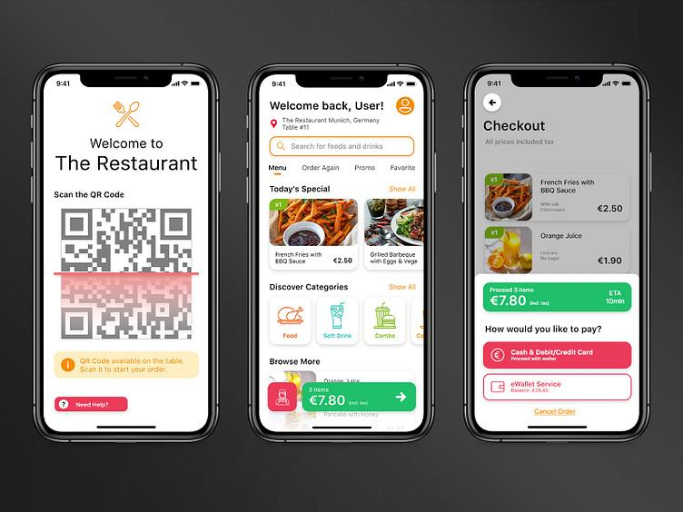

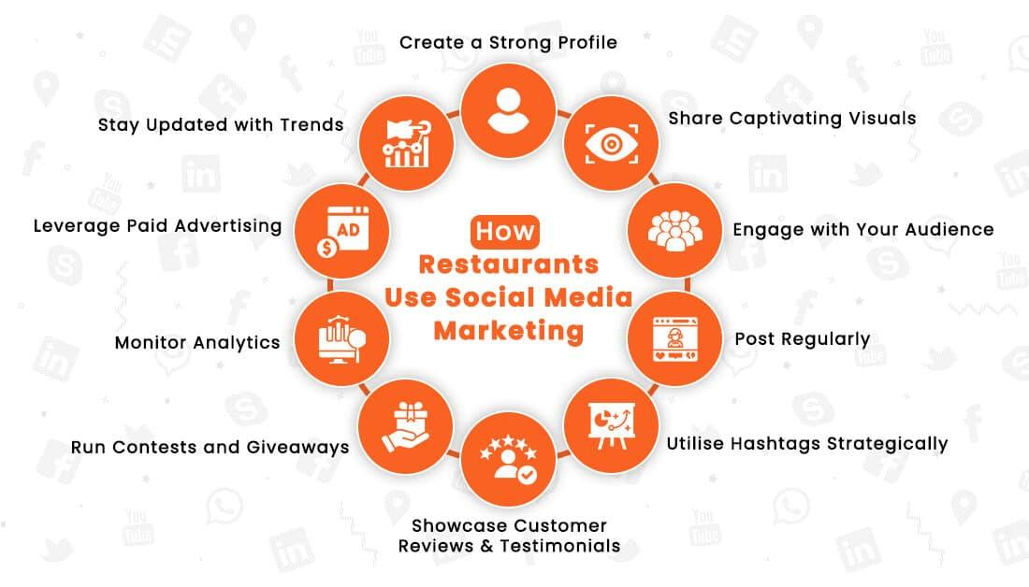

1. Political
Government policies and initiatives can affect how the restaurant adopts digital technology.
Examples:
- Government support for digitalisation of small businesses.
- Government initiatives encouraging businesses to adopt digital solutions.
- Regulations concerning online platforms and digital transactions.
Impact on ABC Café:
Government digitalisation programmes could make it easier and more affordable for the restaurant to adopt new digital systems.

2. Economic
Economic conditions influence customers' spending and the restaurant's technology investments.
Examples:
- Inflation increases food and operating costs.
- Customers may become more price-sensitive.
- Online delivery platforms charge commissions.
- Technology implementation requires investment.
Impact on ABC Café:
During an economic downturn, customers may reduce restaurant spending, while the café may also have less money available for digital transformation.

3. Social
Changes in customer behaviour can strongly influence digital strategies.
Examples:
- Customers increasingly use smartphones to order food.
- Customers rely on online reviews before choosing restaurants.
- Social media influences food choices.
- Customers expect convenient digital ordering and payment.
Impact on ABC Café:
The café could use Instagram and TikTok to promote new menu items and encourage customers to order online.

4. Technological
Technology creates new ways for the restaurant to operate and interact with customers.
Examples:
- Artificial intelligence (AI)
- Mobile ordering
- QR-code menus
- Digital payments
- Cloud-based POS systems
- Customer data analytics
- Automated chatbots

Impact on ABC Café:
The café could use customer data to identify popular dishes and provide personalised promotions.

5. Legal
Digital businesses must comply with laws governing data, advertising and online transactions.
Examples:
- Personal data protection requirements.
- Rules governing digital advertising.
- Consumer protection laws.
- Cybersecurity requirements.
- Regulations relating to electronic transactions.
Impact on ABC Café:
If the café collects customers' names, phone numbers and purchasing information for a loyalty programme, it must handle that data appropriately.

6. Environmental
Digitalisation can have both positive and negative environmental effects.
Examples:
- Reducing paper through digital receipts.
- Energy consumption from digital devices and servers.
- Electronic waste from obsolete equipment.
- Environmental impact of delivery operations.
- Sustainable packaging promoted through digital campaigns.
Impact on ABC Café:
The café could introduce digital receipts and use its online channels to promote environmentally friendly packaging.

Complete Digital PESTLE Example
PESTLE | External Digital Factor | Potential Impact on ABC Café
Political | Government digitalisation initiatives | Easier adoption of digital technologies
Economic | Rising costs and delivery commissions | Pressure on profit margins
Social | Customers prefer mobile ordering | Increased demand for online ordering
Technological | AI and data analytics | Opportunities for personalisation
Legal | Data protection regulations | Need to protect customer information
Environmental | Demand for sustainable practices | Opportunity to reduce paper and packaging waste

Digital PESTLE vs Digital SWOT
This distinction is particularly useful for students:
Digital PESTLE asks:
"What is happening in the external environment that could affect our digital business?"
Digital SWOT asks:
"Given our internal capabilities and the external environment, what are our strengths, weaknesses, opportunities and threats?"
For example:
PESTLE identifies:
Customers increasingly prefer mobile food ordering.
SWOT could then interpret this as:
Opportunity: Develop a mobile ordering system.
Another example:
PESTLE identifies:
Data-protection regulations are becoming more important.
SWOT could then interpret this as:
Threat: Failure to comply could result in reputational or financial consequences.
Easy way for students to remember
PESTLE = Look outside the business 🔎
SWOT = Look inside + outside the business 🎯
So, in a Digital Business Strategy exercise, students can use PESTLE first to understand the external digital environment, and then use SWOT to determine what the organisation should do about it.

